Mapson Instruments
by James Mapson
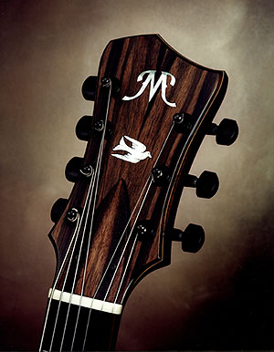
My early direction in archtop guitar building followed the popular 17" acoustic design with floating pickup. The first instrument I built was just such a design and was for my own personal use. I still have this instrument, and it usually is available for demo at my shop in Southern California as well at the various guitar shows I exhibit each year. This instrument turned out quite well, and was even used recently by Mundell Lowe for the big band recording session for Playboy Jazz Labels' 'Blonde' CD and movie soundtrack. | 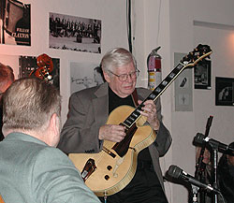  Mundell Lowe
Yet as I began to market my instruments, I became alerted to various problems with the acoustic archtop, especially ones that frustrate the professional musician. At the top of the list was feedback under adverse gig conditions. Also high on the list were ergonomics, amplified electric balance over the fingerboard, and neck/tuning stability. The frequency of which these topics came up when in the presence of professional players, convinced me to re-evaluate my direction in building. Along with the three acoustic models I build, I have now developed three additional models that address the professional players needs specifically. I also offer variants of the original acoustic models that gig-proof them for certain musicians.
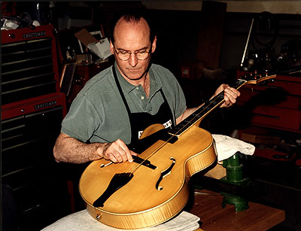
James Mapson
Many players compensate (perhaps subconsciously) with their playing technique to accomplish live performances over which they have very little control to avoid feedback issues. Others have given up on the acoustic archtop entirely, and switched to solid body style instruments to avoid performance problems. Although this is a solution per se, I don't consider it an optimum one. These instruments, for the typical jazz guitarist, are a 'cure' that kills the 'patient'. There are a few notable exceptions to this statement; Ted Greene and Ed Bickert come quickly to mind.
I believe the ideal performance jazz instrument must retain, to some extent, the plate vibration of the traditional acoustic Archtop, and therefore must have a box construction that contains 'airspace' between the plates. This gives color to the amplified tone that is immediately identifiable in jazz guitar recordings, all the way back to Charlie Christian.
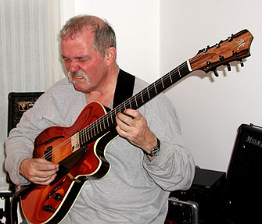
John Abercrombie
About 5 years ago I had a discussion about this topic with Ron Eschete', a 7 string virtuoso based in Los Angeles California. Ron had been playing a couple of instruments for about a decade, that were built around his specifications. When the first one was delivered, he was not satisfied with the amplified performance, and subsequently switched the pickup to an active (battery required) pickup made by EMG. This pickup improved the tonal response over the wide range of the seven strings (7th tuned to low A).
If you have been fortunate to see Ron play, you already know the genius of his chord melody playing. The music Ron performs and his approach to arranging and reharmonization, including his use of polychords, places more demands on the instrument than the typical customer. I knew that Ron must have some great insight to the problems I was trying to address in instrument design, and I convinced him that if we put our heads together, the result would be an improved instrument design.
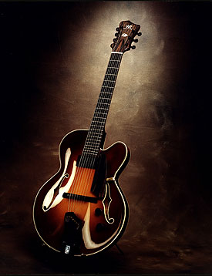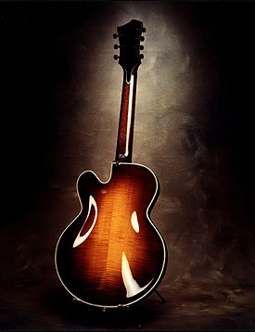
Over the course of the next 6 months, we met many times, to put down on paper a list of goals leading to an improved 7-string design. There would have to be feedback suppression as his current instruments incorporated, but in addition we added the need for better neck stability through out the year, or the resistance to seasonal humidity variations. Also we added the need to stay in tune for the entire gig, even if things got hot on the bandstand or the sudden rush of air conditioning cooled things off quickly, or even performing outdoors where the early evening humidity and temperature changes normally raise havoc on stringed instruments. We discussed his desire for stable notes that sustained equally, very important qualities to support the four note polychord voicings he frequently uses. Having an instrument with such qualities would open up the entire fingerboard for additional voicings. Note that if any note dies prematurely, the polychord fails. Ron really wanted a Fender Rhodes pianistic response in one sense, yet the instrument must retain the nuances of a guitar. Finally the design must be more comfortable wherever possible. His current instruments were 8 and ¼ lbs and 7 and ¾ lbs.
I spent the next 12 months constructing the instrument. Nearly weekly, Ron would stop by and observe the process that he called, "cuttin' wood". In more than one instance, I would build duplicate parts, and prior to assembly, Ron would participate in the tap response evaluation and selection so that we ended up with parts that were dissimilar in pitch by at least a semitone.
The design specs follow:  16" lower bout, 1 and 7/8" rib height  25" scale, 22 frets, 2.050 nut width, 7 ¼" radius  Final weight with pickup and battery: 6 3/4 lbs  European Spruce top, European Maple back and sides, Honduran Mahogany neck  Gabon Ebony fingerboard, Macassar Ebony tailpiece, pick guard, and peg head overlay  EMG active Humbucker and tone circuit | 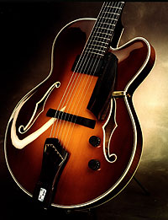
Some key design specifics:
For resistance to environmental changes, special care was taken to seal all wooden surfaces. I wanted to avoid the bother of a humidifying device, something Ron had been accustomed to using. The thinner body depth of 1 7/8" would make for more comfortable playing, but necessitated the design of a different neck joint. I came up with a 'terraced tenon' style joint, which, along with neck reinforcement below the fingerboard and the deletion of the typical floating neck extension, resulted in very stable neck geometry.
In addition to the above, in striving to provide more stable tuning, even balance over the entire fingerboard, and long, equal sustaining properties to the notes, I included a suspended tone bar internally, and designed a precision hinged, height adjustable tailpiece to replace the common violin style attachment that is being promoted these days. The tone bar, with a fundamental tap tone ½ step from the body, is my approach to controlling the acoustics's ability to interfere with the electric performance of the guitar. The tailpiece eliminates the directional instability inherent in the violin design resulting in more stable and accurate tuning. The height adjustment allows the break angle of the strings over the saddle to be increased or lessened to adjust the string resistance or feel to the player as well as altering the sustaining quality of the notes. These are concepts that are well known to players and builders of solid and semi-solid body electric guitars, but seem to evade even the most prestigious archtop luthiers of today. A notable exception to the rule would be the late James L. D'Aquisto.
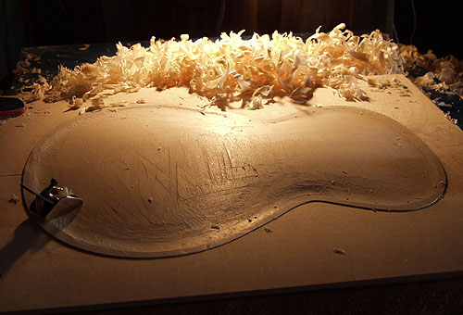
In the 2+ years since completion of Ron's instrument, I have been encouraged observing it's unique traits. In use, it has become Ron's main gigging and recording instrument, and can be heard on several CDs now in print. This instrument has proven to be an extremely accurate and stable platform under the constant busy schedule Ron keeps up. The lighter weight and slim body dimensions make for greater playing comfort, and yet the instrument sounds 'bigger' than it looks. The instrument also holds pitch well under adverse conditions due to the precision neck joint, reinforcement, and sealed inner surfaces. Most importantly, because of its' even balance and long sustain, Ron can now access virtually any chord or polychord in any position or variant he desires, without worrying about areas of the fingerboard that might have contained 'dead' or feedback prone notes.
I would suggest that readers listen to the soundtracks of a recently released CD entitled, 'No Place to Hide'. It can be located on Cdbaby.com, and is a duet recording in which Ron accompanies Mort Weiss on clarinet:
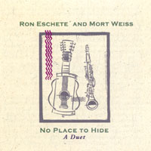 | RON ESCHETE' & MORT WEISS: no place to hide  A sumptuous blend of seven string guitar and clarinet in classic jazz standards and bebop. 'Straight ahead' jazz
Although I put a lot of effort and time into designing and building performance instruments, if I have done my job correctly, the instrument just disappears in the hands of the player, becoming a transparent channel from which the music flows. Ron's playing truly exhibits what can be accomplished on the modern seven-string Archtop guitar, when there is 'no place to hide'.
Ron Eschete' offered these thoughts on his guitar:
The main idea with this guitar was to make it clean in all registers. Warm in the top, clean in the bottom, so you can hear every pitch clearly. I think we have succeeded in filling these demands with this guitar. Whether you play open A, A at the 5th fret it's alive and well everywhere. I can do Freddie Green style comping, chord melodies, back-up work for singers, have a awesome sweet tone, and even get a real raucous tone with Joey DeFrancesco, all out of the same guitar. I love it!  I always wanted a thin guitar with a big sound, less mass, but the same tone. Everyone wants to play loud without feedback, and this guitar solves that problem. I'll play with my Evans amp on 7 (Volume) and 7 (Master) without any problems.  Another facet to the tonality of the guitar is how it is set up with strings and electronics. I use EMG pickups, specifically the EMG-91. This is a great sounding pickup. I also use custom string gauges from GHS. My strings are 13.5p, 16p, 22 flat, 30flat, 40flat, 50 bright flat, and 70 Boomer Round on the 7th string. To keep the guitar evenly voiced I use brighter sounding strings the lower they are tuned. I use the Evans Brain (200w head) and Raezer cabs, specifically the New York 8 and the 1x12" cab. I also use Dunlop Jazz 3 picks, the red or black ones.  The Mapson guitar I have is the best instrument I have played. It is small and light but sounds big. I am very happy with this guitar. | 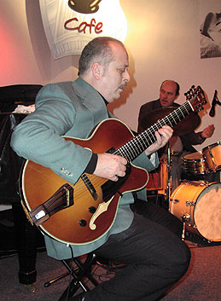
Ron Eschete' has an upcoming book with Mel Bay Publications, Inc.
For more information on Mapson Guitars visit - http://www.archtops.com/
For more information on Ron Eschete' visit - http://www.revjazz.com

